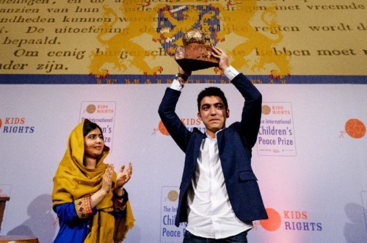
Hero:
Mohamad Al Jounde

ThinThinking

Thinking & Discussion: W2.2homework
Professor Jennifer

Name: _______________ Class: ___________ Date: _________

Mohamad Al Jounde from Syria wins International Children’s Peace Prize 2017
Monday, December 4, 2017 - 15:00
Sixteen-year-old Mohamad Al Jounde from Syria has won the International Children’s Peace Prize. In the Hall of Knights in The Hague Mohamad received the award for his tireless efforts to ensure the rights of Syrian refugee children. In the presence of media outlets from all over the world and several prominent guests, such as His Royal Highness Prince Ali bin al-Hussein of Jordan and a large number of foreign ambassadors, the award was handed out by Nobel Peace Prize Laureate and Children’s Peace Prize winner Malala Yousafzai. Mohamad, himself a refugee as a consequence of the Syrian civil war, has amongst other things built a school in a Lebanese refugee camp. The International Children’s Peace Prize is an initiative of KidsRights, the foundation committed to defending children’s rights worldwide.
During the award ceremony Malala emphasized the importance of Mohamad’s work by pointing out that worldwide there are currently 28 million displaced children. The Syrian civil war alone has led to 2.5 million child refugees, most of whom have bad or no access to education. Malala: "As Mohamad knows, Syria's future depends on it's children - and their future depends on education. Despite all they have personally suffered, Mohamad and his family have helped many children go to school. I am proud to support his efforts and honored to present him with the International Children's Peace Prize."
A born aid worker
Mohamad grew up in Syria, but when it became too dangerous he was forced to flee to Lebanon along with his family. As is the case for thousands of Syrian child refugees, Mohamad was not able to go to school. Together with his family he has built a school in a refugee camp in Lebanon that nowadays provides 200 children with their right to education. As a twelve-year-old already, Mohamad was teaching Math and English to his peers. Currently, he uses photography and games to help children cope with their traumas, learn and have fun.
KidsRights: prevent a lost generation of Syrians
According to Marc Dullaert, founder and chairman of the KidsRights Foundation, the Expert Committee of the Children’s Peace Prize sees Mohamad as a paragon of the strength that children possess to bring about positive change. “Mohamad is a true changemaker: confronted with what for many of us would seem as an unsurmountable challenge, he decided to change the destiny of himself and his peers in the refugee camp.”
Still, Dullaert emphasizes, children cannot do it all by themselves. KidsRights therefore demands that the international community fulfills its promises to the Syrian refugees. The education funds, for example, that were promised at several donor conferences have only been paid out partially. The countries involved with providing shelter for refugees in the region have so far not been able to provide access to education for child refugees.
Dullaert warned the attending guests in The Hague today that a lost generation of Syrians is looming. “For children and youngsters, education is the key to having a future. To prevent a lost generation, the access to education is a basic requirement. For it is this generation that will have to rebuild Syria when the war is over. From a humanitarian standpoint we are obligated to provide access to education for the Syrian child refugees in the region”, Dullaert states. He says to understand how large numbers of refugees have come to Europe: “When every possibility of having a future is missing, people are forced to build their future elsewhere. Education is not a luxury but a basic need. It promotes stability and helps to meet the psychological and social needs of children affected by conflict.”

Questions:

1. What is the International Children’s Peace Prize, and for how many years has it been given?
____________________________________________________
2. Why was Mohamad Al Jounde chosen for the International Children’s Peace Prize?
____________________________________________________
3. Who presented the award, and why is she important?
____________________________________________________
4. What is KidsRights calling the international community to do?
____________________________________________________
5. According to this article, why is education important?
____________________________________________________
6. What do you think are some characteristics of a hero?
____________________________________________________
7. If you could meet a hero that is living today, who would you want to meet?
____________________________________________________

