Unit 4 Grammar: Frequency Adverbs
%
Name: ___________________ Class: _________________Date: _____________

Rewrite the sentences using the correct frequency adverb:
always, usually, often, sometimes, never.

1. Greg, June, and Leo swim at the beach in summer. (75%)
______________________________________________________________________________

2. They are tired after final exams. (100%)
______________________________________________________________________________

3. Mary goes to the gym in the evening. (50%)
______________________________________________________________________________

4. I ride the bus home after work. (75%)
______________________________________________________________________________

5. He takes the subway to school. (0%)
______________________________________________________________________________

6. She is sad after watching a sad movie. (100%)
______________________________________________________________________________

7. We watch TV on weekends. (25%)
______________________________________________________________________________

8. I am hungry early in the morning. (0%)
______________________________________________________________________________

9. Do Hoon has kimchi with all his meals. (75%)
______________________________________________________________________________

10. You are late to class. (25%)
______________________________________________________________________________
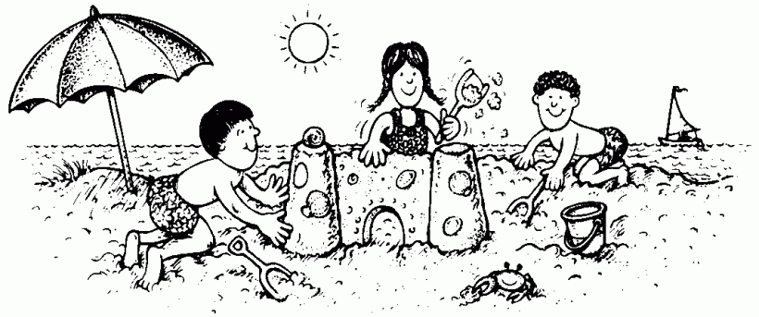

Answer the following questions with an

expression of frequency:

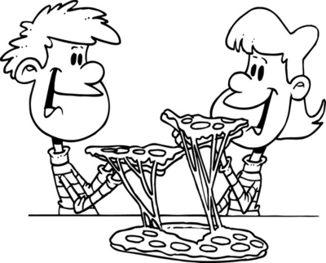
never
every day
once a day
twice a day
three times a day
Monday
Wednesday
Saturday
every other day
“three times a week”

1. How often do you eat pizza?
______________________________________________________________________________

2. How often do you drink milk?
______________________________________________________________________________

3. How often do you play computer games?
______________________________________________________________________________

4. How often do you go to the movies? (go to the movies = go to the cinema)
______________________________________________________________________________

5. How often do you take a shower?
______________________________________________________________________________

6. How often do you go to the gym?
______________________________________________________________________________

7. How often do you go home? (home = your hometown, not dormitory)
______________________________________________________________________________

8. How often do you call your parents? (call = call on the phone)
______________________________________________________________________________

9. How often do you go shopping for clothes?
______________________________________________________________________________

10. How often do you check your email?
______________________________________________________________________________

