“Seasons of Love”
Written for “RENT” Today’s performance: “GLEE”

Five hundred twenty-five thousand six hundred ______________
Five hundred twenty-five thousand moments so ____________
Five hundred twenty-five thousand six hundred minutes
How do you _________________, measure a _________________?
WORD BANK
minutes x2
seasons x3
daylights
hundred
cups
love x3
laughter
dear
measure x2
coffee
life
year

story
cried
woman
thousand
friends
celebrate
she
remember
bridges
plan
man
died
journeys
sing
In _________________, in sunsets
In midnights, in __________________ of ________________
In inches, in miles, in _________________, in strife
In five hundred twenty-five thousand six ______________minutes
How do you ________________, a year in the ______________?
How about _____________? How about ___________?
How about love? Measure in __________________
________________ of love.
Five hundred twenty-five thousand six hundred ______________
Five hundred twenty-five thousand ______________to ______________
Five hundred twenty-five ______________ six hundred minutes
How do you measure the life of a ______________ or a ______________?
In truths that ______________learned. Or in times that he ______________
In ______________ he burned. Or the way that she ______________
It's time now, to ______________ out. Though the______________never ends
Let's ______________. Remember a year in the life of ______________
______________ the love (x2) Measure in love…..
________________ of love. ______________ of love.

Song Background
“Seasons of Love" is a song from the Broadway musical Rent, written and composed by Jonathan Larson. The song starts with an ostinato piano motif, which provides the harmonic framework for the cast to sing "Five hundred twenty-five thousand, six hundred minutes" (the number of minutes in a common year [60 minutes × 24 hours × 365 days]). The main instruments used throughout the song are piano, vocals, guitar, organ, bass and drums.
The song is performed by the entire cast in the musical and in the 2005 film of the same name. The lyrics ask what the proper way is to quantify the value of a year in human life, concluding in the chorus that the most effective means is to "measure in love". Since four of the lead characters either have HIV or AIDS, the song is often associated with World AIDS Day and AIDS awareness month.

Composer: Jonathan Larson
Jonathan Larson actually intended for "Seasons of Love" to be performed symbolically as a song at Angel's funeral. When Larson died the night before the preview opening of the show, the cast sang it at the beginning to pay their respects to the composer. Larson died unexpectedly the morning of Rent's first preview performance Off Broadway. He suffered an aortic dissection, believed to have been caused by undiagnosed Marfan syndrome, in the early morning on January 25, 1996.
It is performed at the beginning of the second act, referencing recent past events or the events to come.

Reflection

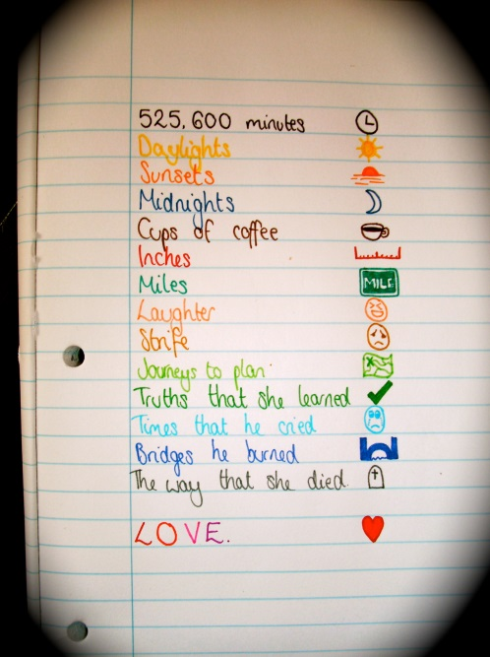
- What is your favorite line from this song? Why?

- Have you ever met someone who lives their life with great love?

- Who is your hero? Does that person measure his/her life in love? How?

