Complete the first sentence together: “We use the simple present for ___________________, _______________________ and __________________________.”

Vocabulary

Look at the picture. Write a complete sentence describing the person’s job.
1. | Alex  _____________________________________
2. | Josh  ______________________________________

3. | Sally & Jen  ________________________________________
4. | 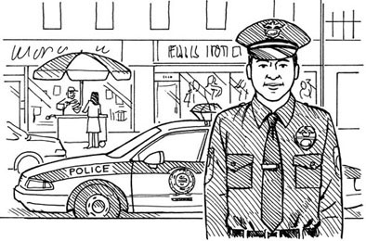  Brent  _______________________________________

Use the clues to complete the sentence about the person’s job.

5. | She's ________________________________. She works in a hospital.
6. | He's __________________________________. He works in a school.
7. | Michelle is __________________________. She works at a construction site.
8. | Johnny is _____________________________.  He acts in movies.

Write the Correct 3rd person form of the verbs

9. sing ____________ 10. study ______________ 11. relax ______________

12. have ____________ 13. do ______________ 14. play ______________

Grammar
Choose the correct words to complete the question AND write it in the BLANK.
17. | Who ____ for?
 | A) | do he works
 | B) | does he work
 | C) | do he work

15. | What ____?
 | A) | do you do
 | B) | does they do
 | C) | do he does
16. | What ____?
 | A) | is Jessica do
 | B) | does Jessica do
 | C) | do Jessica do

18. | Where ____?
 | A) | do Paul and Beth lives
 | B) | do Paul and Beth live
 | C) | does Paul and Beth live
19. | Where ____ to school?
 | A) | is Joe go
 | B) | does Joe go
 | C) | do Joe goes
20. | How old ____?
 | A) | are you
 | B) | do you do
 | C) | does she is

Is the sentence grammatically correct (C) or incorrect (I)? Circle the correct answer.

21. Where do your brother and sister live? C / I 22. I doesn’t live in Ireland. C / I

23. His wife doesn’t go to Harvard. C / I 24. My father doesn’t works in a hospital. C / I

25. Carlos and I works in an airport. C / I 26. My sister Mara lives in San Francisco. C / I

Reading

I’m Jenny. Meet My Friends
Alex | My friend Alex is from Los Angeles. But now he lives in Mexico City. He’s 27, and he’s an actor. He works in theaters in Mexico and the US. I think he has an interesting job.
Yukiko | Yukiko is a doctor. Her husband Kabuo is an architect. They live in Osaka, Japan. Yukiko works in a small hospital in Osaka. Kabuo works in an office in the city center. Yukiko is 29.
Soo-Hee | My friend Soo-Hee lives in Busan. That’s in Korea! She’s a chef, and she works for the Phoenix Hotel. Soo-hee is 23. She loves her job!
Sarah | Sarah is 25. She’s an English teacher. Sarah works in a school in Taipei. She lives in Taipei, too. Sarah has a lot of students!

27. Alex lives in Canada. T / F 28. Kabuo works in Osaka. T / F

29. What does Jenny think about Alex’s job?
____________________________________________________________________________________

30. Where does the teacher live?
____________________________________________________________________________________

31. How old is the doctor?
____________________________________________________________________________________

32. How does Soo-Hee feel about her job?
____________________________________________________________________________________

